ESME Workbench 2012: NMCI Testing Protocol for HP/Navy Testing Group

This document outlines a procedurally-based operations guide for use and testing of the ESME workbench. This document is provided as supplement to the ESME Quick Start Guide, and is specifically targeted for users operating NMCI-certified machines, which have higher than normal computational overhead. Successfully completing all steps of this document should be regarded as an indication that the functionality of ESME has been demonstrated for a reasonable use-case.

## 04 November 2013

# Installation

Prerequisites

* A 32-bit or 64-bit Windows XP or 7 installation, with all service packs and recommended windows update packages installed. The .NET framework v. 4.0 will be installed automatically if required.
* A network connection or standalone installation media.

The installer has either been provided to you or can be downloaded from <http://esme.bu.edu/download> . For a 64-bit operating system which has never had ESME installed on it before, the appropriate file is <http://esme.bu.edu/download/ESME%20Application%20and%20Databases-x64.exe> .

The installer should complete successfully after some time – it will consume approximately 2.0 GB of hard drive space when fully installed. A desktop shortcut and start menu group (with additional menu options) will be installed.

# First Launch

The first time ESME launches, it will display the following message box:

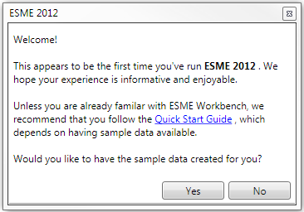

**For the purposes of NMCI testing and validation, sample data does NOT need to be created, and the user should select “No”.**

ESME will launch and display a blank map.

# Location Creation

A Location is a set of coordinates in which a Simulation may be created (and, subsequently, all further work performed). Locations are represented on the map by a colored rectangle.

Locations are created by selecting the “Create New Location” button on the Location Panel:

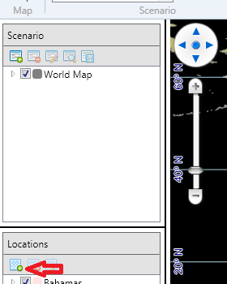

A dialog box will pop up. Enter a name (eg, “Test Location”), and the coordinates that specify a test scenario off the coast of Massachusetts: North 43 degrees, South 42 degrees, East -69 degrees, West -70.5 degrees.

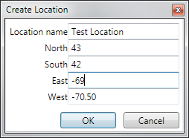

Click OK. During this process, a blue rectangle with adjustable vertices will move around on the map to the position indicated by these coordinates. Once OK is clicked, a solid rectangle will replace it:

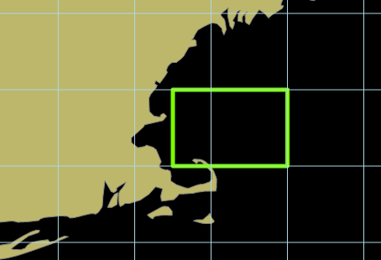

A list item named “Test Location” will appear in the Locations sidebar.

# Scenario Creation

Scenarios can be created in three ways: by clicking the “Create” button under the Scenario subgroup on the Ribbon toolbar, by clicking the “Create new scenario” button on the Scenario toolbar, or by a context menu item on the “Scenarios” sub menu item in the Location toolbar:

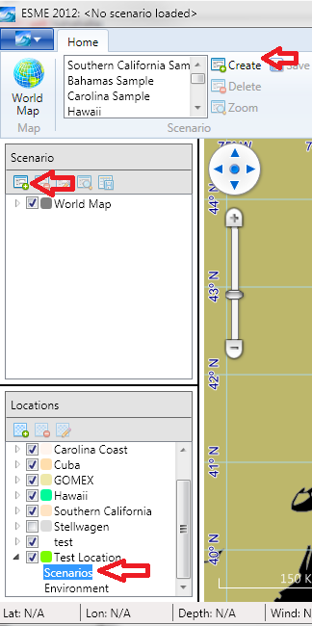

All three options launch the same Scenario creation dialog box:

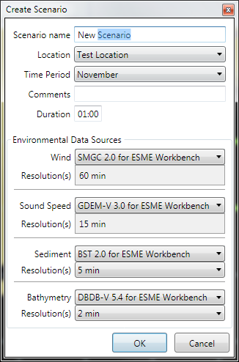

Rename the scenario to “Test Scenario”, and hit OK. The default values for the four environmental data sources are acceptable for testing.

The Scenario Panel will populate with information:

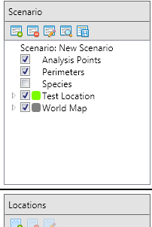

Expanding the “Test Location” menu item will display check-able boxes, each of which will render an opaque layer to the map with environmental information (here, bathymetry)

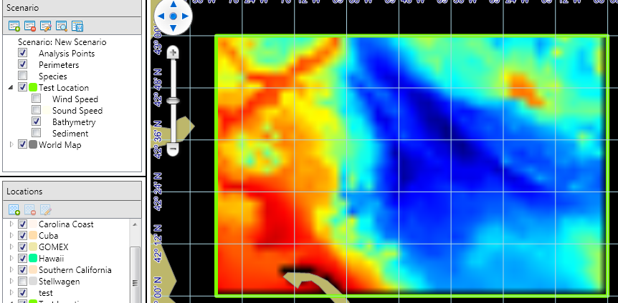

The scenario is now successfully created. Click the SAVE icon to preserve state.

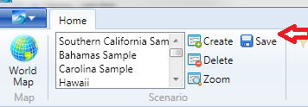

# Scenario population

Scenarios require at least one Acoustic Source (one Platform, one Source, and one Mode); one Analysis Point, and one Species to run a simulation.

## Adding Acoustic Sources

Right click on the Scenario:New Scenario text and select “Add Platform”.

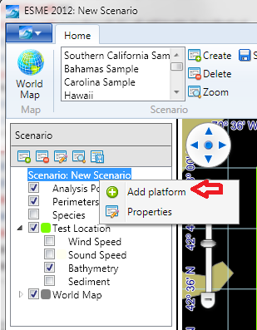

A new sub-menu item will appear. Press Enter or ESC to confirm its name as “New Platform”, then right-click on it and select “Add Source”:

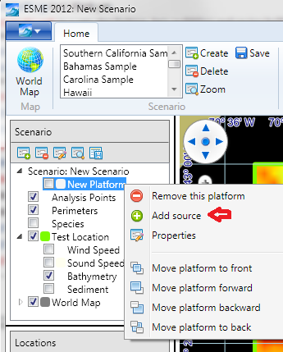

And repeat to add a new Mode:

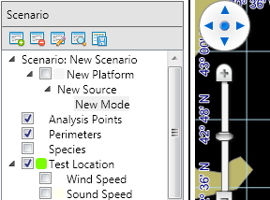

The default settings for a new mode are acceptable, and do not need to be modified. However, right-clicking on New Mode will allow them to be viewed or modified via a context menu option.

### Adding a Perimeter, and configuring Platform Movement.

Right-click on Perimeter, and select “Add Perimeter”. Similar to how new Locations are created, a map object will appear. Click OK to keep it centered in the middle of the location:

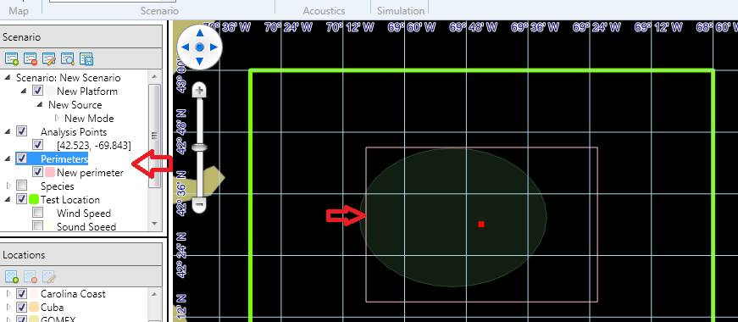

Next, right click on the Platform “New Platform” and select “Properties”

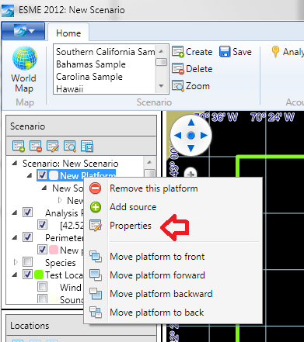

1. Assign the platform to the Perimeter.
2. Change its behavior to “Perimeter Bounce”
3. Change its speed to 10.
4. Check “Randomize”
5. Click OK.

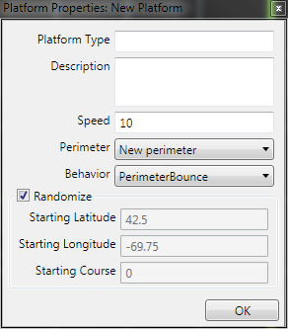

Save the Scenario.

## Adding a new Analysis Point and Computing Transmission Losses

The Analysis Point button on the Ribbon Bar should now be enabled.

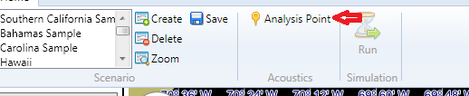

Clicking on it will transform the mouse cursor into a crosshair. Create a new analysis point by clicking inside the Location boundary a reasonable distance from the edge. With the bathymetry unselected for clarity, a circle will appear inside the area, and the Acoustic Simulator indicator in the bottom toolbar will indicate 16 Items have begun calculation:

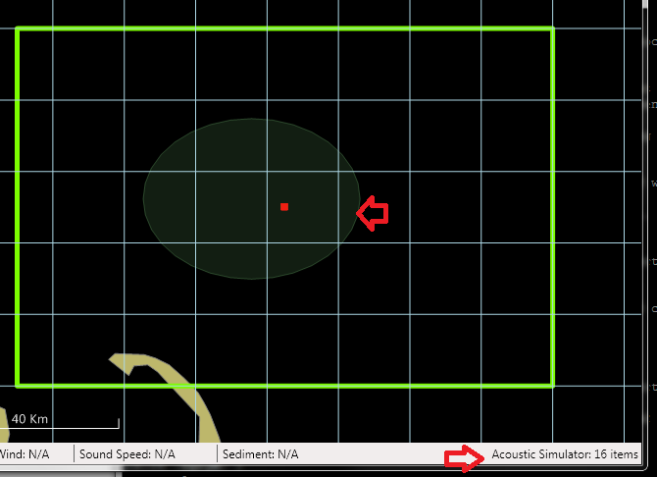

Allow all 16 items to complete. Once the toolbar reads “Acoustic Simulator: Idle”, save the scenario again.

## Adding a Marine Mammal Species

In the Scenario panel, right click on “Species”, and select “add new species”:

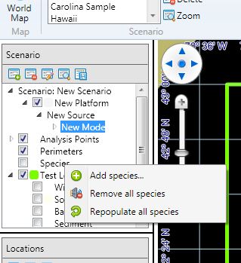

And select the default options in the dialog:

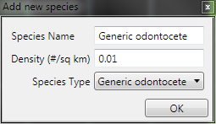

Toggle the checkbox to display marine mammals on the map:

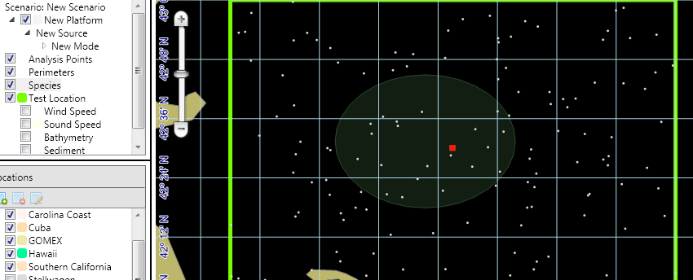

Save the Scenario.

# Transmission Loss Visualization

Transmission losses can be visualized in a separate window. Open the Analysis Points menu item to show the only Analysis Point, and double click on it to display the transmission losses that were calculated there:

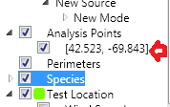

The transmission loss viewer will launch:

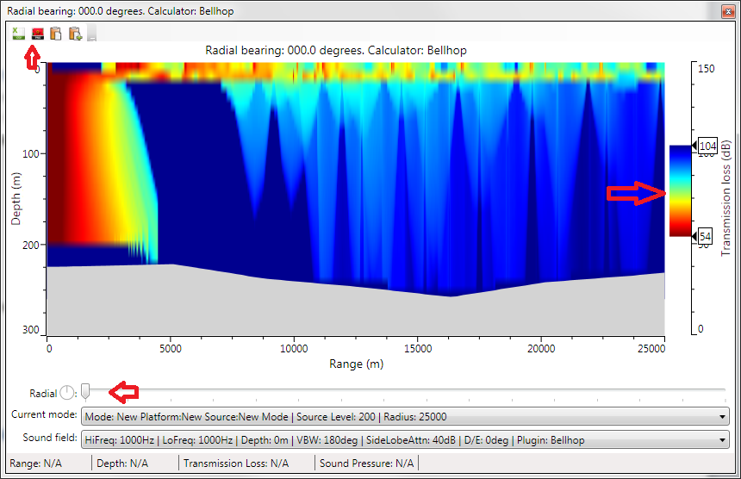

Moving the radial slider will update the display. Sliding the color bar will adjust the display. Double clicking on the color bar will expand it to full-size. Double clicking again resets it to the default statistical range. Menu options exist for saving the selected radial to disk as a CSV file, or as one of several graphics types.

# Simulation

The Simulation Button on the ribbon toolbar will be clickable:

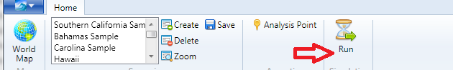

This will launch the Simulation configuration dialog:

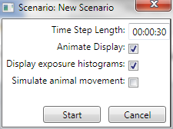

Clicking Start begins the simulation. The dialog remains, and a progress bar is displayed. A new window appears with histograms populating in them. Once the simulation has completed, the dialog box closes automatically and the histograms remain until closed manually.

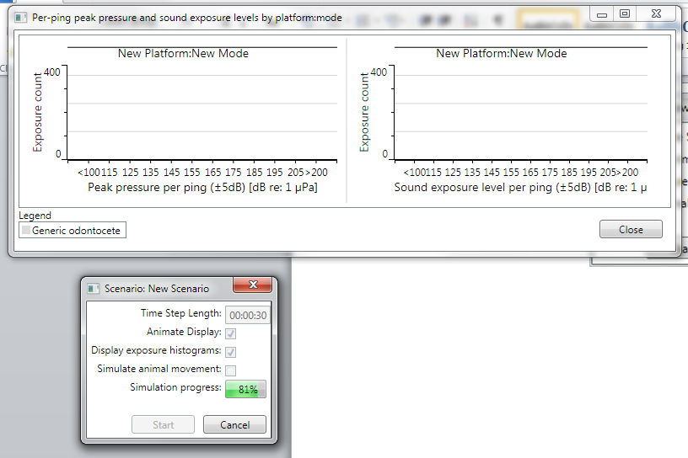

### Conclusion